1. 对自己做的任何程序的JSP页面进行JSTL的改写，练习JSTL及EL标签的使用。

**Dome.java**

**package** sy9;

**import** java.io.Serializable;

**public** **class** dome **implements** Serializable{

**private** String name;

**private** String password;

**public** String getName() {

**return** name;

}

**public** **void** setName(String name) {

**this**.name = name;

}

**public** String getPassword() {

**return** password;

}

**public** **void** setPassword(String password) {

**this**.password = password;

}

**public** **boolean** isMatch() {

**return** "tipu".equals(name) && "123456".equals(password);

}

}

**Login.jsp**

<%@ page language=*"java"* contentType=*"text/html; charset=utf-8"*

pageEncoding=*"utf-8"*%>

<!DOCTYPE html PUBLIC "-//W3C//DTD HTML 4.01 Transitional//EN" "http://www.w3.org/TR/html4/loose.dtd">

<html>

<head>

<meta http-equiv=*"Content-Type"* content=*"text/html; charset=utf-8"*>

<title>登 录</title>

</head>

<body>

<form action=*"login2.jsp"* method=*"post"*>

<br>用户名：<input type=*"text"* name=*"name"*></br>

<br>密&nbsp码：<input type=*"text"* name=*"password"*></br>

<input type=*"submit"* value=*"submit"*>

</form>

</body>

</html>

**Login2.jap**

<%@ page language=*"java"* contentType=*"text/html; charset=UTF-8"*

pageEncoding=*"UTF-8"*%>

<%@taglib prefix=*"c"* uri=*"http://java.sun.com/jsp/jstl/core"*%>

<jsp:useBean id=*"user"* class=*"sy9.dome"*></jsp:useBean>

<jsp:setProperty name=*"user"* property=*"*"* />

<!DOCTYPE html PUBLIC "-//W3C//DTD HTML 4.01 Transitional//EN" "http://www.w3.org/TR/html4/loose.dtd">

<html>

<head>

<meta http-equiv=*"Content-Type"* content=*"text/html; charset=UTF-8"*>

<title>登录页面</title>

</head>

<body>

<c:choose>

<c:when test=*"*${user.match }*"*>

<h1><jsp:getProperty property=*"name"* name=*"user"*/>登录成功</h1>

</c:when>

<c:otherwise><h1>登录失败</h1></c:otherwise>

</c:choose>

</body>

</html>

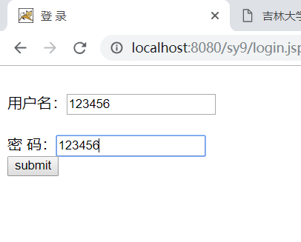

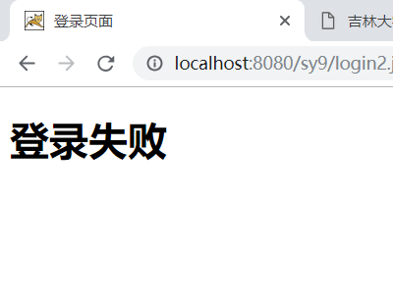

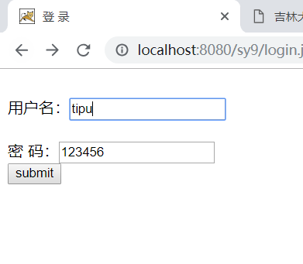

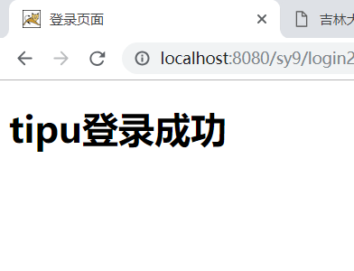

2.课后实训题P282

**Show.jsp**

<%@ page language=*"java"* contentType=*"text/html; charset=UTF-8"*

pageEncoding=*"UTF-8"*%>

<%@taglib prefix=*"fmt"* uri=*"http://java.sun.com/jsp/jstl/fmt"* %>

<%@ page import=*"java.util.*,javax.servlet.jsp.jstl.fmt.*"*%>

<!DOCTYPE html PUBLIC "-//W3C//DTD HTML 4.01 Transitional//EN" "http://www.w3.org/TR/html4/loose.dtd">

<%**if**(session.getAttribute("pro")==**null**)

session.setAttribute("pro", "sy9.change_en_US");

%>

<fmt:bundle basename=*"*${sessionScope.pro}*"*>

<html>

<head>

<meta http-equiv=*"Content-Type"* content=*"text/html; charset=UTF-8"*>

<title>change the langues</title>

</head>

<body>

<a href=*"chan?id=e"*>English</a>&nbsp&nbsp&nbsp&nbsp<a href=*"chan?id=f"*>繁中</a>&nbsp&nbsp&nbsp&nbsp<a href=*"chan?id=j"*>简中</a>

<hr>

<h1><fmt:message key=*"change"*></fmt:message></h1>

</body>

</html>

</fmt:bundle>

**Chan.java**

**package sy9;**

**import java.io.IOException;**

**import javax.servlet.ServletException;**

**import javax.servlet.annotation.WebServlet;**

**import javax.servlet.http.HttpServlet;**

**import javax.servlet.http.HttpServletRequest;**

**import javax.servlet.http.HttpServletResponse;**

**import javax.servlet.http.HttpSession;**

**@WebServlet("/chan")**

**public class chan extends HttpServlet {**

**protected void doGet(HttpServletRequest request, HttpServletResponse response) throws ServletException, IOException {**

**request.setCharacterEncoding("UTF-8");**

**HttpSession session=request.getSession();**

**String id=request.getParameter("id");**

**if(id.equals("e"))**

**session.setAttribute("pro", "sy9.change_en_US");**

**else if(id.equals("f"))**

**session.setAttribute("pro", "sy9.change_zh_TW");**

**else if(id.equals("j"))**

**session.setAttribute("pro", "sy9.change_zh_CN");**

**request.getRequestDispatcher("show.jsp").forward(request,response);**

**}**

**}**

